SELECT * FROM `kasir` WHERE alamat = 'Malang';

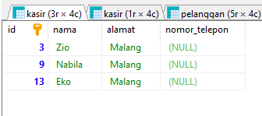

SELECT * FROM `kasir` WHERE alamat = 'Klaten';

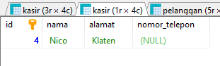

SELECT * FROM `pelanggan` WHERE alamat = 'Tangerang';

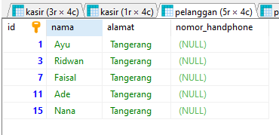

SELECT * FROM `pelanggan` WHERE alamat = 'Yogyakarta';

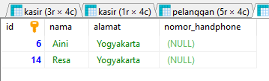

SELECT * FROM `obat` WHERE harga >= 5000;

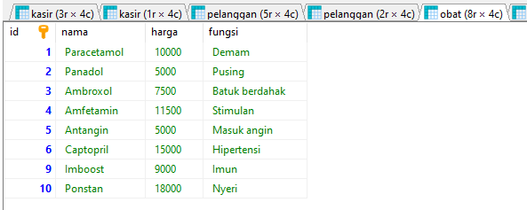

SELECT * FROM `obat` WHERE harga <= 5000;

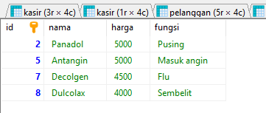

SELECT * FROM `stok` WHERE stok <= 50;

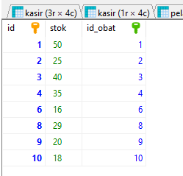

SELECT * FROM `stok` WHERE stok >= 50;

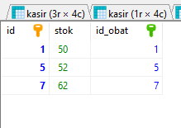

SELECT * FROM `transaksi` WHERE jumlah_transaksi <= 5;

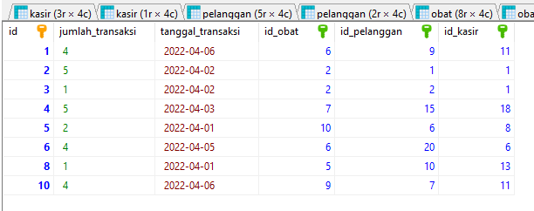

SELECT * FROM `transaksi` WHERE jumlah_transaksi >= 5;

